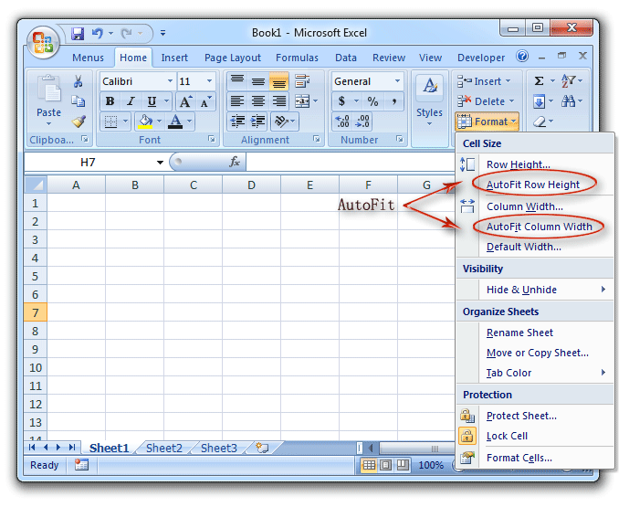
Alternative:
Select every cell in the whole sheet with ctrl-A:
- Resize a column a little wider (all the columns will get wider)
- Double-click a row separator - the row height will be auto-fitted
- Double-click a column separator - the column widths will be auto-fitted

